Data definition

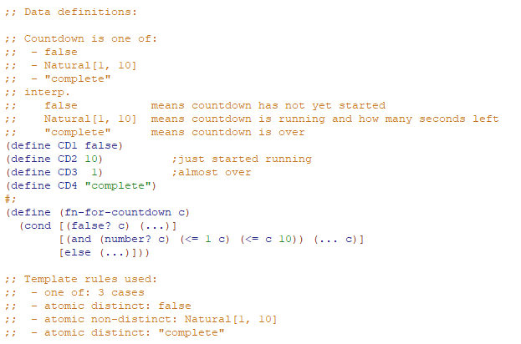

Function definition

**Signature, purpose, and stub**



Run as often as you can to find mistakes early!

**Examples**

Recipe -> Itemization -> Guidance on Data Examples and Function Example/Tests

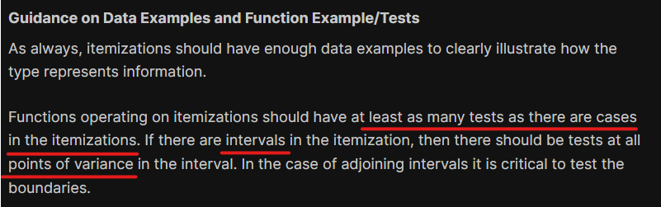

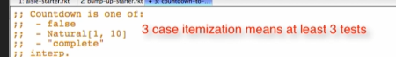

1st case false:



2nd case interval: Natural[1,10]



* But in our problem, we do not really need the **position** of the number in the interval, thus we only need 1 test, not every point of variance or every point of boundary



3rd case “complete”:

 Run and check if well-formed.

Note:

* We are making a lot of decisions about the function’s behavior while working on examples
* This is to make the code body step easier (or decrease its complexity)

**Template**

Comment out stub and copy template from data definition. Rename the function name

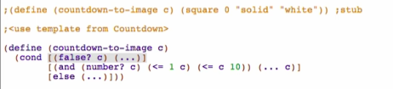

**Code Body**

1st case:

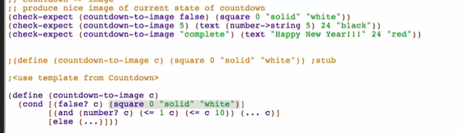

2nd case:

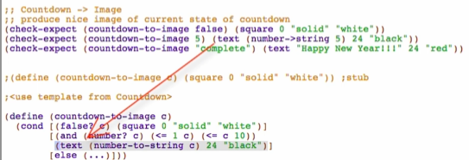

3rd case:

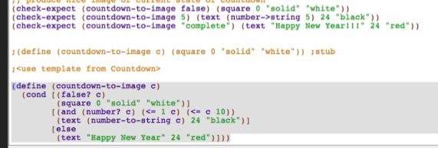

Run and debug

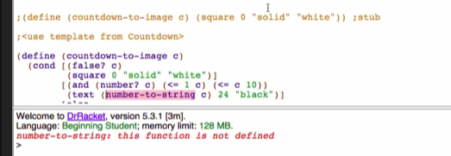

Fix:



Run and debug:



Fix: 

Run and debug:



Rename Refactorings Tool

1. Click Check Syntax
2. Hover over definition or call to see relation between definitions and uses
3. Right-click, choose rename

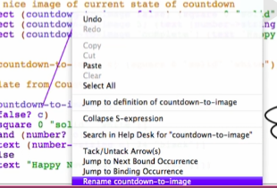

1. Rename your function

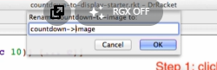

Note: does not rename COMMENTED names